**Cyber Forensics Practical 7**

**Aim:-** Recovering and Inspecting deleted files

- Check for Deleted Files

- Recover the Deleted Files

- Analyzing and Inspecting the recovered files

Perform this using recovery option in ENCASE and also Perform manually through command line

**Step 1:** Open AccessData toolkit and click on file🡪new case.

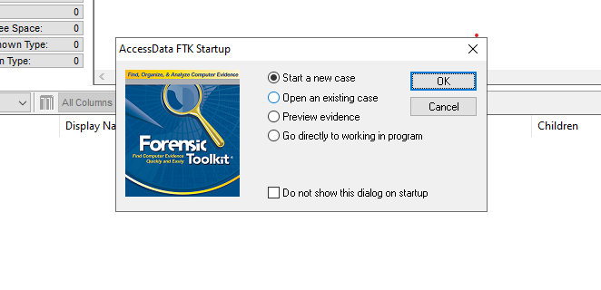

**Step 2:** Fill the following details and click next.

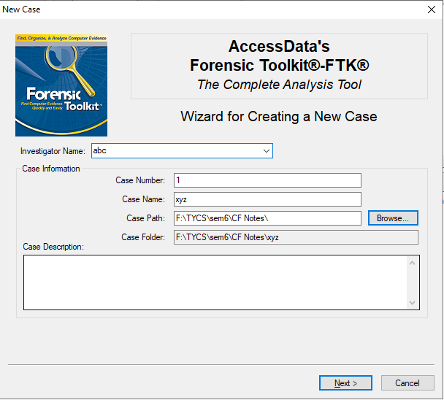

**Step 3:** Click next.

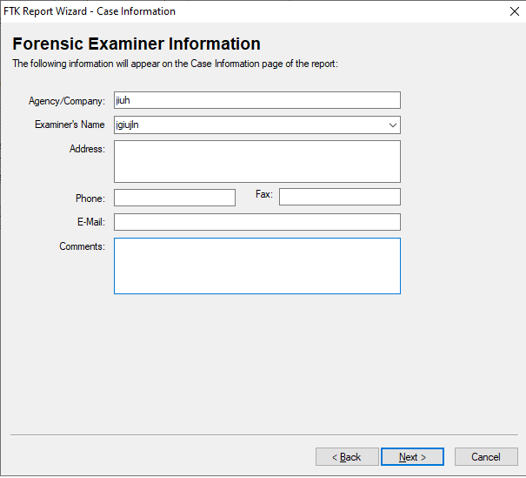

**Step 4:** Click next.

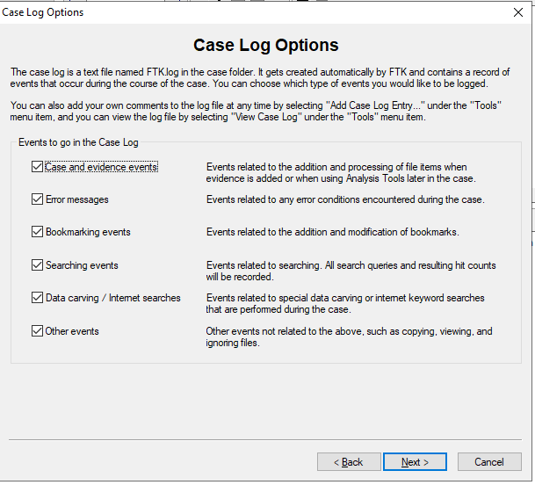

**Step 5:** Select all and Click next.

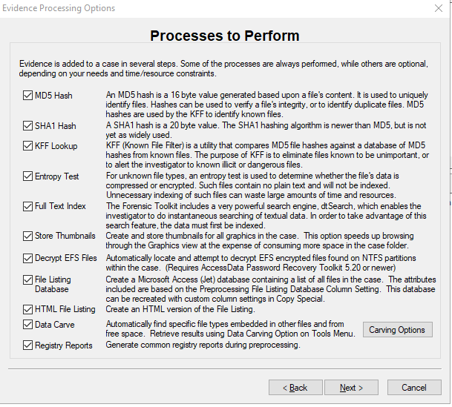

**Step 6:** Fill the following and click next.

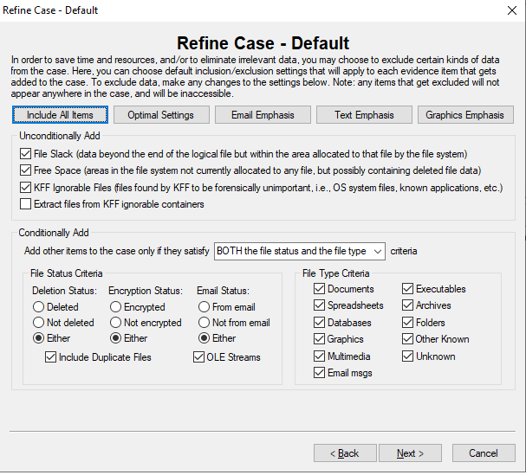

**Step 7:** Click next.

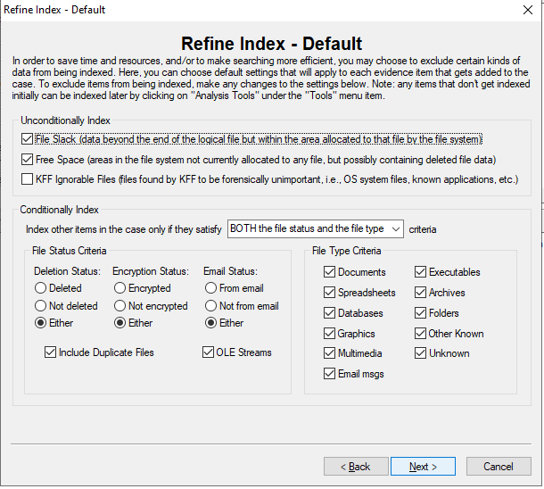

**Step 8**: Add evidence.

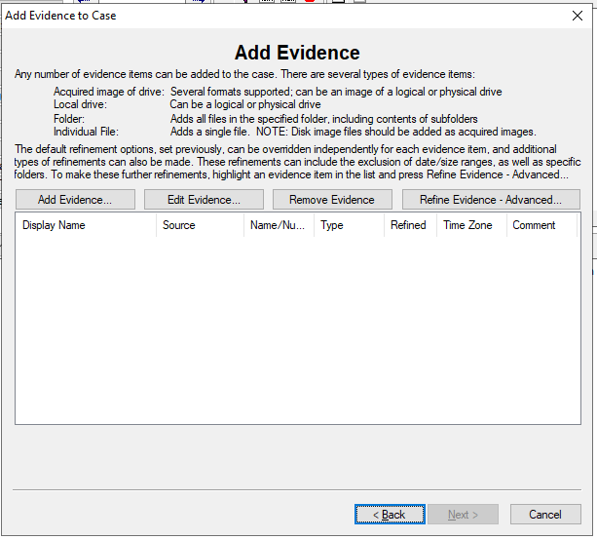

**Step 9:** Fill the following and click OK.

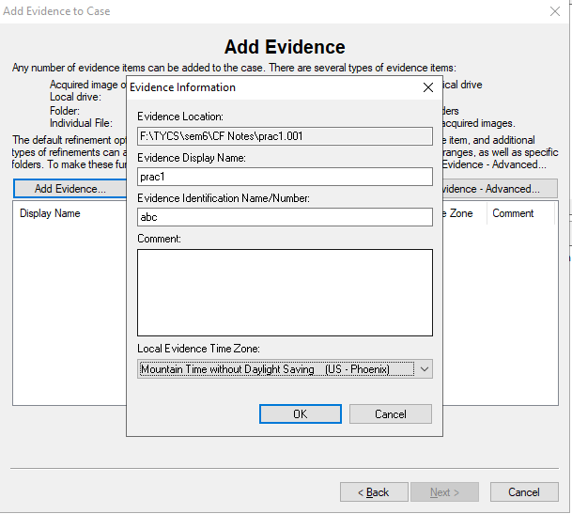

**Step 10:** Click next.

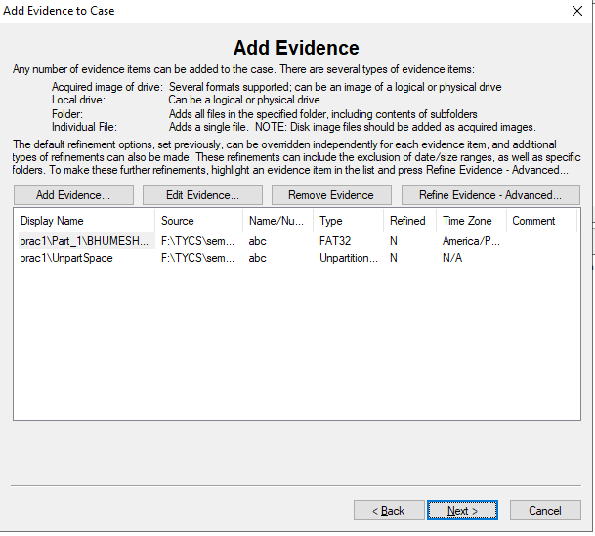

**Step 11:** Click finish.

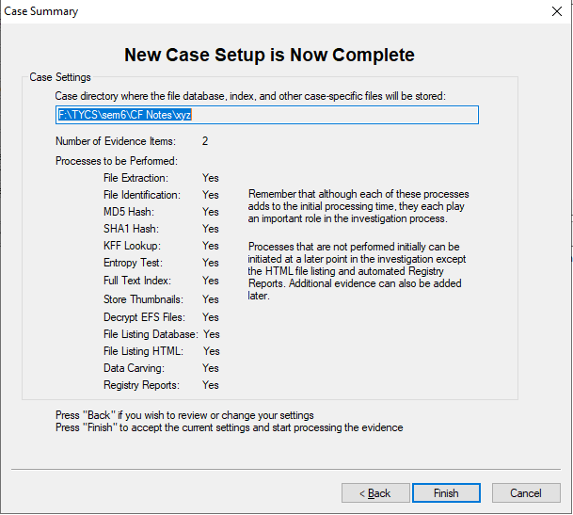

Let the process complete.

**Step 12:** Let the carving complete.

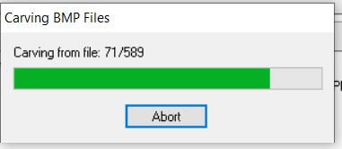

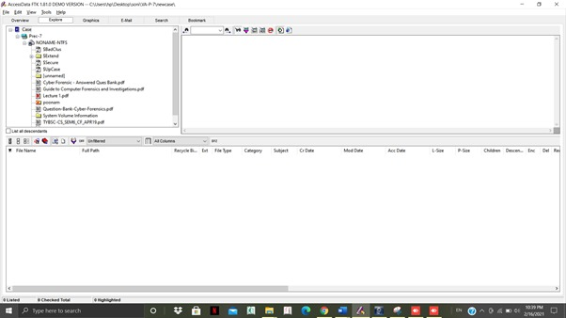

**Step 13:** Find deleted files.

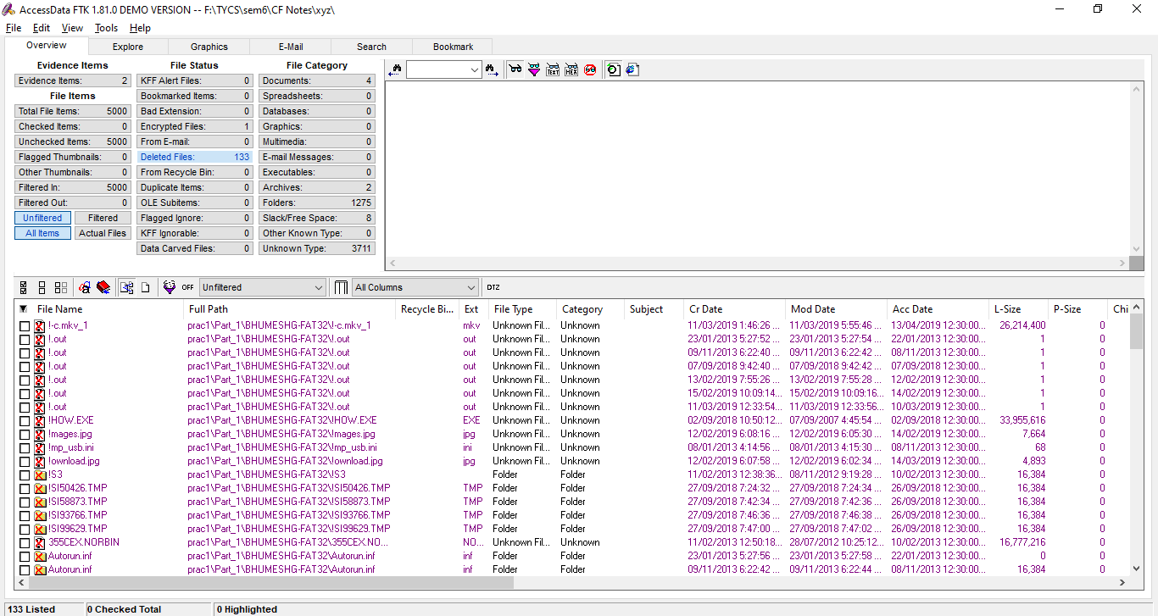

**Step 14:** Extract deleted files.

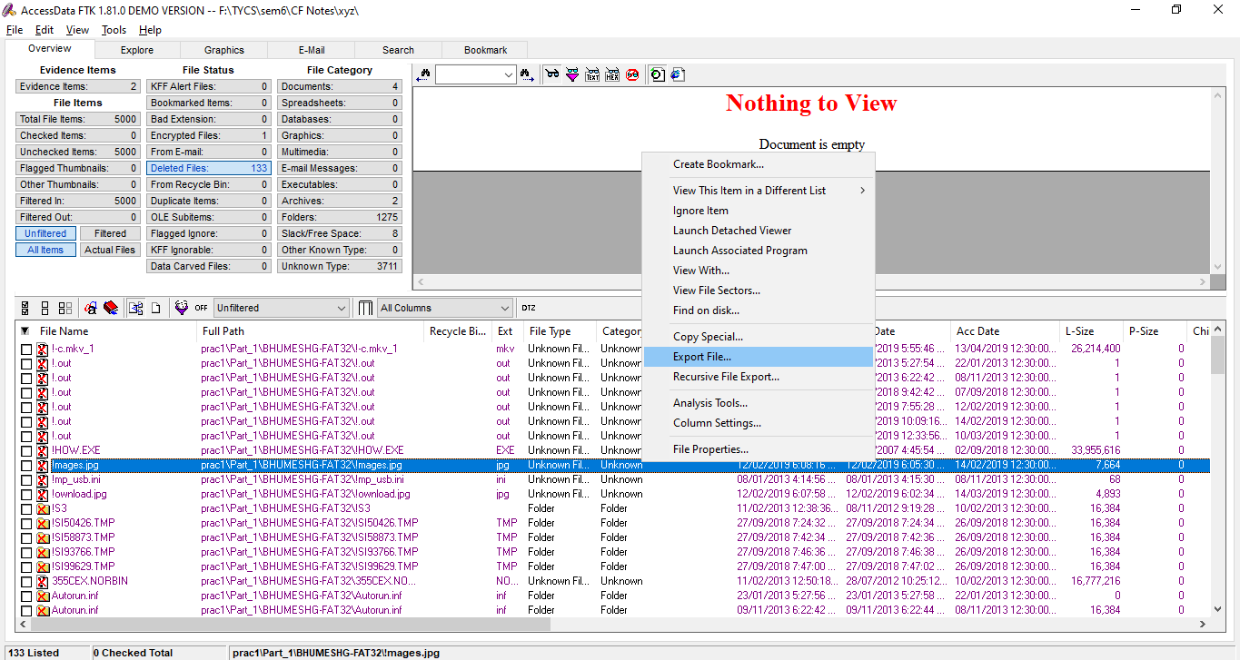

**Step 15:** Deleted files recovered.

